K5 BOOK LIST

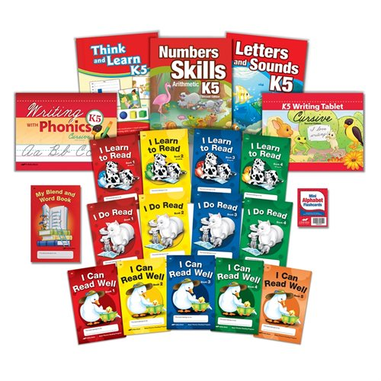
- K5 Child Kit
Item Number: 327778

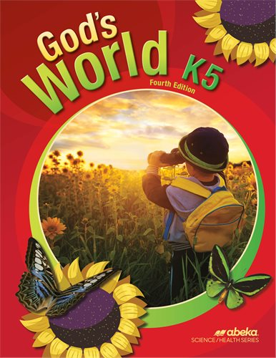
- God’s World K5
Item Number: 99600

- Social Studies K5
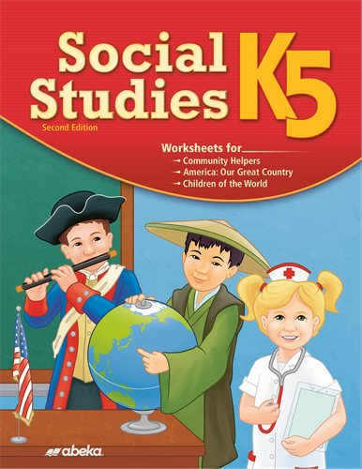
Item Number: 302538

